COS80022 – Software Quality and Testing

Assignment 1 (P&C)

Student Name: Arun Ragavendhar Arunachalam Palaniyappan
Student ID: 104837257
Student email: 104837257@student.swin.edu.au
Submission date: 14/04/2024

TASK 1: Requirements Documentation for ‘Pay Fine’ Scenario

1.1 Introduction:
A complete system study is required to write the technical business requirement documents of any complex system. Hence, to analyse, design and implement the complete backend system of a Library system, it is very important to draft the requirements specifications of the system.

The full list of functionalities of this particular backend system of a library include various functions like:

- User Login
- Searching for a book in the catalogue
- Accessing Physical and Electronic items
- Borrowing a book
- Paying the fine
- Renewing loans
- Placing a book on Hold
- Asking a librarian
- Booking a room
- Viewing and updating a borrower’s account
- Accessing databases
- Generating Usage reports, Etc.

These functions are accessible to actors and other entities based on their role and their authority/access within the University environment.

This specific requirement document has been written for the “Pay Fine” scenario functionality of the backend of a University Library system. This document has been done with some creative assumptions after a thorough discussion with the client regarding their specific functionality requirements.

1.2. Purpose and Scope of the system:

The main purpose of this document is to lay down the specific functional requirements which stress about the features and capability of the system for the “Pay Fine” use case, the non-functional requirements which specifies about the security, usability, performance, etc., as well as the constraints and assumptions for this scenario with all the necessary details.

The requirement document includes the definitive system requirements and includes details about the calculation of fines for different users like students and staffs. It also includes the rules and definition of how the borrower record and book catalogue record is updated.

1.3. Functional Requirements:

Login and Validation:
First of all, a borrower must have a registered borrower’s account and must login to the system and validate using his/her bar code ID. Once the authentication is successful, access is allowed to

- Borrower Account Records - shows the fine overdue and other details of the borrower
- Book Catalogue Records - shows the book details, count and status

Borrower Account Records:
- Borrower details and the fine details are listed here, which must be paid and cleared by the borrower.
- Once the borrower pays and clears fine, the record is updated to show the updated “Fine Overdue”.

Borrower ID | Name | Type | Date of Birth | Department | Status | Fine Overdue
STU34578 | Arun | Student | 22/08/1999 | Computer Science | Active | A$35
TA43216 | Patrick | Staff | 09/03/1987 | Civil Engineering | Active | A$17
STU45673 | Ravi | Student | 17/11/1995 | Bio Technology | Inactive | A$5

Book Catalogue Records:
- Book records, count and date borrowed and status are maintained in this record.
- Once a book is returned, the date borrowed column is cleared and book status is changed to “Available”.

Item ID | Item Name | Book Count | Date Borrowed | Status
SE3451 | Database Management | 23 | 27/03/2024 | Borrowed
DE5691 | Graphic Designing | 4 | 30/03/2024 | Borrowed
ME1486 | Fluid Mechanics | 17 | - | Available

Calculation rule for the fine Amount:
Fine amount is differently calculated for a student and a staff. A staff pays less fine than a student as a staff concession.

Student:

- If an item that has been borrowed is renewed or returned within 14 days, then there is no fine.
- Once, it exceeds 14 days, then there is a $5 AUD base mandatory fine, which gets added to by an addition of 50 cents for every subsequent day after that.

- For example – If a book is not returned for 18 days. This means on the 15th day, there is a fine of $5AUD and another $1.5AUD for the next 3 days (50 cents per day x 3)
- Hence, the total fine amount being - $6.5AUD.

Staff:

- If an item that has been borrowed is renewed or returned within 14 days, then there is no fine.
- Once, it exceeds 14 days, then there is a $3 AUD base mandatory fine, which gets added to by an addition of 25 cents for every subsequent day after that.

- For example – If a book is not returned for 18 days. This means on the 15 days, there is a fine of $3AUD and another 75 cents for the next 3 days (25 cents per day x 3)
- Hence, the total fine amount being - A$3.75AUD.

Fine Amount limit and payment:
If the total fine amount a borrower vows is more than $25AUD, he/she cannot renew or borrow any item without clearing the full fine amount.
However, if the amount is lower than $25AUD, the borrower can choose to make a partial payment, more details of which is discussed in the constraints section.

Payment Option and selection:
The Borrower can select the amount to be paid off (partial or full) and can pay using card or electronic transfer. But the payment has to be made in person with a librarian, who will then update the payment is the system and will also offer a payment receipt.

User preview and Confirmation page:
Before making the payment, the librarian shows a preview summary page of the total due amount of the selected fine amount to be paid, as well as the chosen payment method.

Payment Processing and confirmation:
The library system connects with the bank through an external gateway and the payment is processed and confirmed once done.

Bill Generation:
The borrower gets a detailed and comprehensive receipt of the payment details with the date and time stampings.

New status update of and Borrower Account Records:
- Once a fine is either fully or partially paid, the “Fine Overdue” column of the borrower record is updated with the fine cleared.

Borrower Account Records:
Borrower ID | Name | Type | Date of Birth | Department | Status | Fine Overdue
STU34578 | Arun | Student | 22/08/1999 | Computer Science | Active | 0
TA43216 | Patrick | Staff | 09/03/1987 | Civil Engineering | Active | A$8.5
O456783 | Ravi | Student | 17/11/1995 | Bio Technology | Inactive | A$5

New status update of Book Records:
- Once a book is returned, the book “count” is increased and book status is changed to “available”.

Book Catalogue Records:
Item ID | Item Name | Book Count | Date Borrowed | Status
SE3451 | Database Management | 24 | - | Available
DE5691 | Graphic Designing | 5 | - | Available
ME1486 | Fluid Mechanics | 17 | - | Available

1.4 Non-Functional Requirements:
NFR01:
Use Case: Well defined Security measures
- The credit card validation and payment processing are to be done according to the latest industry protocols and verified through a One Time Password (OTP) validation to the borrower’s mobile number or mail.
Rationale:
- This helps to avoid any unauthorized access, by any fraudulent bodies and helps to secure the borrower data and the payment details from security threats.
NFR02:
Use Case: Usable, Well-Illustrated Menu, fast and responsive User Interface:
- The User Interface should be designed such that it easily guides the borrower through the entire process with neat, proactive prompts and clear, usable instructions.
Rationale:
- This helps the borrowers to clearly understand and act based on their requirements without any confusion/ambiguity on what the user interface actually displays, leading to a reduction of errors and also enhances overall usage satisfaction.
NFR03:
Use case: Reliability
- The system must handle issues like payment delays, transaction updates, handling of transaction failures with proper refund to customer account, ensuring no double tap duplicate payment debits on credit card tap payment methods, all of these, which can occur due to various reasons like hardware and network failures.

Rationale:
- By properly resolving these problems and and issuing appropriate reimbursements, when necessary, a reliable system retains user trust and confidence and give them a peace of mind.
NFR04:
Use Case: Performance
- The system should execute transactions and update catalogue status preferably within 1 second for each page refresh to maintain a good performance standard.
Rationale:
- This is crucial for delivering a consistent user experience and ensuring that transactions are processed on time. By setting a performance objective of 1 second for every page refresh, the system strives to reduce user wait times while improving efficiency and usability.
NFR05:
Use Case: Audit Record
- The system should have an audit trail of all payment transactions, such as borrower ID, amount, payment method, and date, for future reference and reconciliation.
Rationale:
- By storing information such as borrower ID, amount, payment method, and date, the system allows administrators to track and reconcile transactions, spot anomalies or inconsistencies, and maintain transparency and accountability in financial operations.
NFR06:
Use Case: Accessibility
- The system should be designed in a way that it has help support and voice prompts to support people with special needs and should be accessible for everyone.
Rationale:
- The system supports users with disabilities, such as visual impairments or mobility limits, by offering assistance support and voice prompts, allowing them to efficiently access and utilise the system while also fostering inclusion and equitable access to library services.

1.5 Constraints:
- A borrower must either settle all the fines in full or if he/she wants to make a partial payment. Then the due amount must be less than $25AUD and the partial payment amount must be at least 50 percent of the fine amount that is due.
- Unless and until there are any system errors or discrepancies from the external bank payment gateway side, the payments made to the system are final and is non-refundable.
- The overall performance of the system even after a well-defined requirements definition is constrained on the hardware and internet connectivity systems available at the University.

1.6 Risk Analysis:
Risk:
- Inadequate or delayed payment processing as a result of server outages, network problems, or payment gateway malfunctions.
Mitigation:
- To quickly handle payment failures, the system must have strong error handling and retry procedures. To identify and address problems early on, payment processing systems should be routinely monitored.
Risk:
- Private borrower data or payment information might get exposed due to unauthorised access or data breaches.
Mitigation:
- To prevent data breaches, strict security measures should be put in place such as encryption, access limits, and frequent security audits.
- Data privacy laws must be followed to reduce legal and reputational concerns.

1.7 Assumptions:
- The payment process is dependent on the external agencies – banks and their internet banking systems in this case for the payment process. This is assumed to be working fine for a smooth and error free process.
- The regulations of the library regarding fine payment should be followed by the borrower, who should also be aware of the repercussions of not doing so, including loss of borrowing rights.

TASK 2: Use Case Diagram

First of all, the Complete Use case diagram with all possible use cases and actors involved for covering the entire functionality of the library backend system has been presented.

Actors:

- Students
- Staff
- Librarians
- Head Librarian
- IT Support officer
- Technician – for system repair and maintenance
- Backend Database, other external entities integrated to the library system.

Use Cases:

- Login: allowed to all actors
- Borrow Books: allowed to all users
- Renew a loan: allowed to all users
- View Fine Overdue: allowed for students and staff
- Pay Fine: allowed for students and staff
- Ask a Librarian: allowed for students and staff
- Place Hold: allowed for students and staff
- Full Access Browse: allowed for librarians only
- Item Search Catalogue: allowed for all actors
- Create Borrower Account: allowed for librarians only
- Book a room: allowed for all actors
- Add Annual Borrower’s List: allowed for the IT Support officer only
- Reserve /Restrict a Borrowing: allowed for the staff only
- Generate Reports on Item Usage, borrowing rates, etc.: allowed for the head librarian only.
- System Repair and Maintenance: Allowed for Technician only

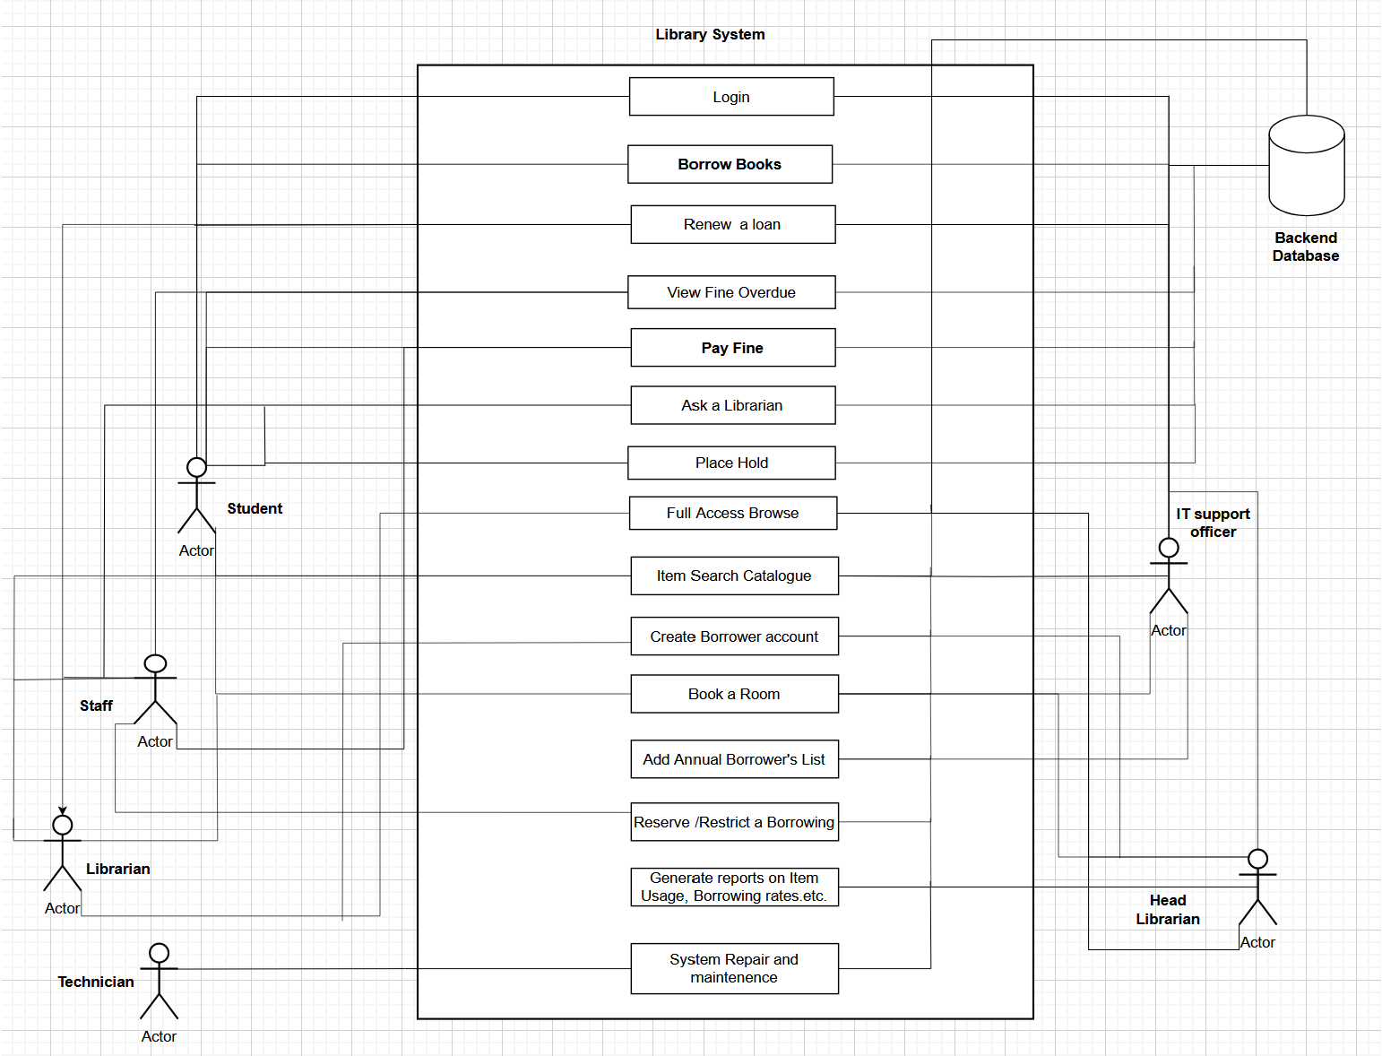

USE CASE DIAGRAM – representing all uses cases and actors

TASK 3: Use Case Textual Description for “Borrowing a book”

Use Case Name | Borrowing A Book
Summary | This specific use case shows the description flow when a borrower searches for, borrows and then returns a book back to the library.
Participating Actors | Primary Actor - Borrower,  Secondary Actors - Librarian, Backend Database system
Flow of Events | 1. Borrower validates his/her ID and logs in to the library system and navigates to the Search Items Catalogue.  2. The system then prompts the borrower to enter the search parameters such book title, author, publication name or genre.  3. Borrower types in the specific search criteria.  4. The system contacts the backend database and retrieves and presents a list of books that fit the search criteria, if a match is found.  5. The borrower picks a book from the list.  6. The system again connects to the backend database and checks for the availability of the chosen book by checking the status and count of the book in the database records.  7. The system checks and verifies if the borrower is eligible to borrow (no pending fines above $25AUD), if the book is “available”.  8.The system will request the borrower to confirm their borrowing activity, if the above step was successful.  9. Borrower verifies their borrowing action.  10. The system changes the book's status to” borrowed”, sets a due date, decreases the book count and logs the transaction for future reference.  11. Borrower receives confirmation for the completed borrowing transaction.  12.The librarian hands over the book to the borrower.  12.The system updates the Borrower's account with the new details of the borrowed items and the Item catalogue of the backend database is also updated about the new status of the book as “borrowed”.  13. Borrower reads a borrowed book.  14. Borrower returns the book to the librarian once done.  15.The system updates the book status back to “available”, marks the date of return, updates the count of the book and logs the transaction for future reference.
Alternative flow | If a match is not found when a borrower searches for a book in the Search Items Catalogue, he/she is redirected back to the Search Item Catalogue page and is asked to retry with a different search criterion.  If a match is found, but the book count is 0 or the book has been blocked/restricted for borrowing, by a staff, then, the borrower is again redirected back to the Search Items Catalogue page and is asked to retry for a different book of choice.
Pre-Conditions | The borrower must have a registered Borrower’s account and must be able to login and authenticate using his/her Barcode to proceed forward to borrow a book.  The book that the borrower is looking for must be available for borrowing. The book should not be blocked /restricted and the book count should not be 0.
Post-Conditions | The return of the book, status and the book count are updated in the Item catalogue records.  The borrower’s account is also updated with the corresponding status.  The date of usage is also calculated and if it exceeds the allowed interval of 14 days, a corresponding fine is updated in the borrower’s account “Fine Overdue” section.
Quality Requirements | Performance: The system should be such that it is both efficient as well as fast enough to fetch a book information quickly  Detailed and Informative User Interface: The confirmation page should clearly show and notify the borrower about the borrowing date, expected return interval as well other important transaction details.  Data Accuracy: The borrower transaction details and the information regarding the availability /unavailability of a book should be accurate and should reflect correctly.

TASK 4: Activity Diagram for “Searching and placing a book on Hold”

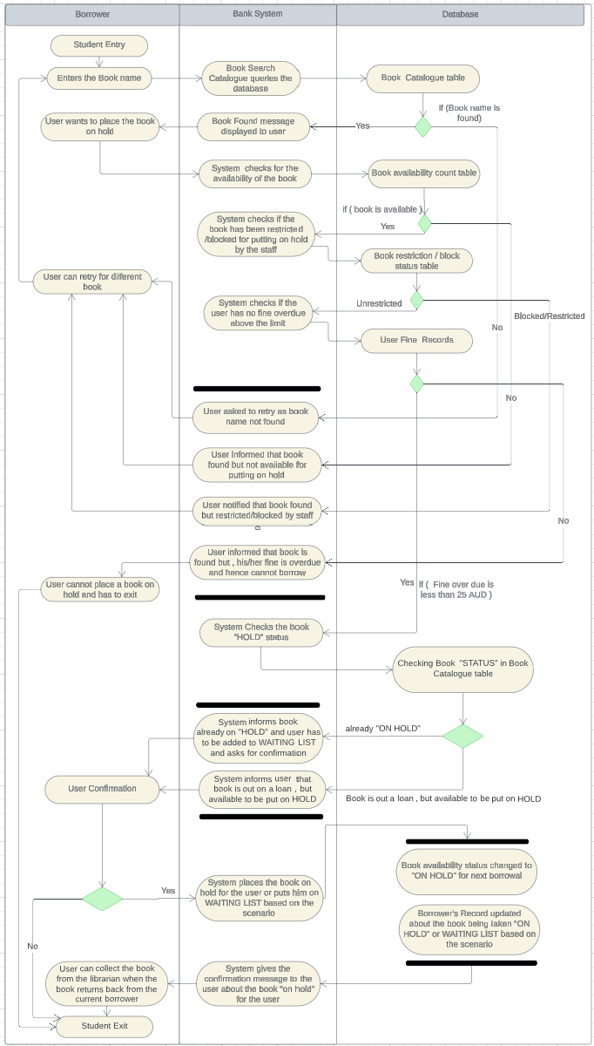
TASK 5: Test Case Generation

The below test cases have been designed and generated using the requirements and design document for Pay Fine Scenario.

Every test case has been designed with
- A unique Test case ID
- Test Case Description
- Test Input
- Expected Result (Oracle)

Since the backend system has not been coded and built yet , it is not possible to showcase an actual result(log) for the test cases.

But these test cases that have been generated can be used to test the system once the coding face is over.

Rules to be followed:

Calculation rule for the fine Amount:
Fine amount is differently calculated for a student and a staff. A staff pays less fine than a student as a staff concession.

Student:

- If an item that has been borrowed is renewed or returned within 14 days, then there is no fine.
- Once, it exceeds 14 days, then there is a $5 AUD base mandatory fine, which gets added to by an addition of 50 cents for every subsequent day after that.

- For example – If a book is not returned for 18 days. This means on the 15th day, there is a fine of $5AUD and another $1.5AUD for the next 3 days (50 cents per day x 3)
- Hence, the total fine amount being - $6.5AUD.

Staff:

- If an item that has been borrowed is renewed or returned within 14 days, then there is no fine.
- Once, it exceeds 14 days, then there is a $3 AUD base mandatory fine, which gets added to by an addition of 25 cents for every subsequent day after that.

- For example – If a book is not returned for 18 days. This means on the 15 days, there is a fine of $3AUD and another 75 cents for the next 3 days (25 cents per day x 3)
- Hence, the total fine amount being - A$3.75AUD.

Fine Amount limit and payment:
- If the total fine amount a borrower vows is more than $25AUD, he/she cannot renew or borrow any item without clearing the full fine amount.
- However, if the amount is lower than $25AUD, the borrower can choose to make a partial payment, more details of which is discussed in the constraints section.

- A borrower must either settle all the fines in full or if he/she wants to make a partial payment. Then the due amount must be less than $25AUD and the partial payment amount must be at least 50 percent of the fine amount that is due.

1.
Test case ID | T101
Test case Description | Student user has fine A$10, want to make a full payment using credit card.
Test Input | Amount A$10, full payment, credit card
Expected Result (Oracle) | Payment successful, Fine overdue = 0

2.
Test case ID | T102
Test case Description | Student user has delayed return of 35 days, wants to view how much the fine is and wants to make a 50 percent partial payment through cash.
Test Input | 35 days overdue, partial payment of 50 percent, cash
Expected Result (Oracle) | Calculated Fine – A$15.5, payment successful,  Fine overdue = A$7.25

3.
Test case ID | T103
Test case Description | Student user has fine of A$18 and wants to make a partial payment of 30 percent of the fine amount using credit card.
Test Input | A$9, partial payment of 30 percent, credit card
Expected Result (Oracle) | “Sorry, you have to make a minimum of 50 percent of the fine amount, to make a partial payment”

4.
Test case ID | T104
Test case Description | Staff user has a fine of A$14 and wants to make a make a full payment through cash.
Test Input | Amount A$14, full payment, cash
Expected Result (Oracle) | Payment Successful, Fine overdue = 0

5.
Test case ID | T105
Test case Description | Staff user has an overdue of 50 days, want to view the fine and make a 75 percent partial payment through credit card.
Test Input | 50 days overdue, partial payment of 75 percent, credit card
Expected Result (Oracle) | Calculated Fine – A$12, partial payment of 75 percent successful, Fine overdue=A$3

6.
Test case ID | T106
Test case Description | Staff user has a fine of A$28 and wants to make a partial payment of 50 percent through cash.
Test Input | Amount A$14, partial payment, cash
Expected Result (Oracle) | “Sorry, your fine overdue is more than A$25, so you cannot make a partial payment.  Please make a full payment”

7.
Test case ID | T107
Test case Description | Student user already has a fine of A$18 and has a current book overdue of 62 days. Now wants to make a full payment through credit card.
Test Input | A$18, 62 days overdue, full payment, credit card
Expected Result (Oracle) | Calculated Fine – A$47, payment successful,  Fine overdue = 0.

8.
Test case ID | T108
Test case Description | Student user has fine of A$8. Wants to make a full payment through an online transaction, but want to do it remotely from his/her home.
Test Input | A$8, full payment, remote payment
Expected Result (Oracle) | “Sorry remote payments are not allowed. Please visit the library and kindly make the payment in person to a librarian”.

9.
Test case ID | T109
Test case Description | Student user is not sure of his/her overdue, wants to view it and make a full payment through credit card.
Test Input | View overdue days and calculate fine, full payment, credit card
Expected Result (Oracle) | No.of. Days. Overdue = 44  Calculated fine= A$20  Payment successful, Fine Overdue = 0

10.
Test case ID | T110
Test case Description | Staff user wants to first renew a loan and then pay the fine overdue.
Test Input | View fine overdue and check if eligible for a renewal
Expected Result (Oracle) | Fine overdue=A$27.  “Sorry. Fine Overdue is more than A$25, you cannot renew again before clearing off the current fine overdue”

11.
Test case ID | T111
Test case Description | Student user wants a make a partial payment of 50 percent to bring his/her fine overdue to below A$25 through cash and then wants to borrow a book.
Test Input | View Fine, pay 50 percent partial payment, cash, check eligibility for borrowing
Expected Result (Oracle) | Fine Overdue before payment=A$28  Payment successful  Updated Fine Overdue = A$14  You are now eligible to borrow a book.

12.
Test case ID | T112
Test case Description | Student User wants to pay fine of A$21 ,50 percent through cash and 50 percent through credit card.
Test Input | A$21, full payment, cash, credit
Expected Result (Oracle) | “Sorry. For a single clearance payment, only a single type of payment method is allowed. Please pay either using only cash or only credit card.”

